1. Acceptance criteria verification: Please manually verify the following acceptance criteria on the following website: https://www.rabbitscams.sex/

Feature:

* + When I enter text in the search box on Rabbits Cams, I expect to see a reference to that text in the provided results.

Scenario 1:

* + Given that I have opened the Rabbits Cams search menu on a mobile device
  + When I add "jenny" to the search box
  + And click the Search Button
  + Then performers with "jenny" in their name should be mentioned in the results

**Verification List:**

**Pass** **Status** – The user can view the performer named “jenny” in the provided results

page.

**Screen Shoot:**



Scenario 2:

* + Given that I have opened the Rabbits Cams search menu on a mobile device
  + When I add "nathanial" to the search box
  + And click the Search Button
  + Then performers with "nathanial" in their name should be mentioned in the results

**Verification List:**

**Fail** **Status** – The user cannot view the performer named “nathanial” in the provided results

page.Instead it displays “Sorry, we can't find any results that match your

criteria.”

**Bug Screen Shoot:**

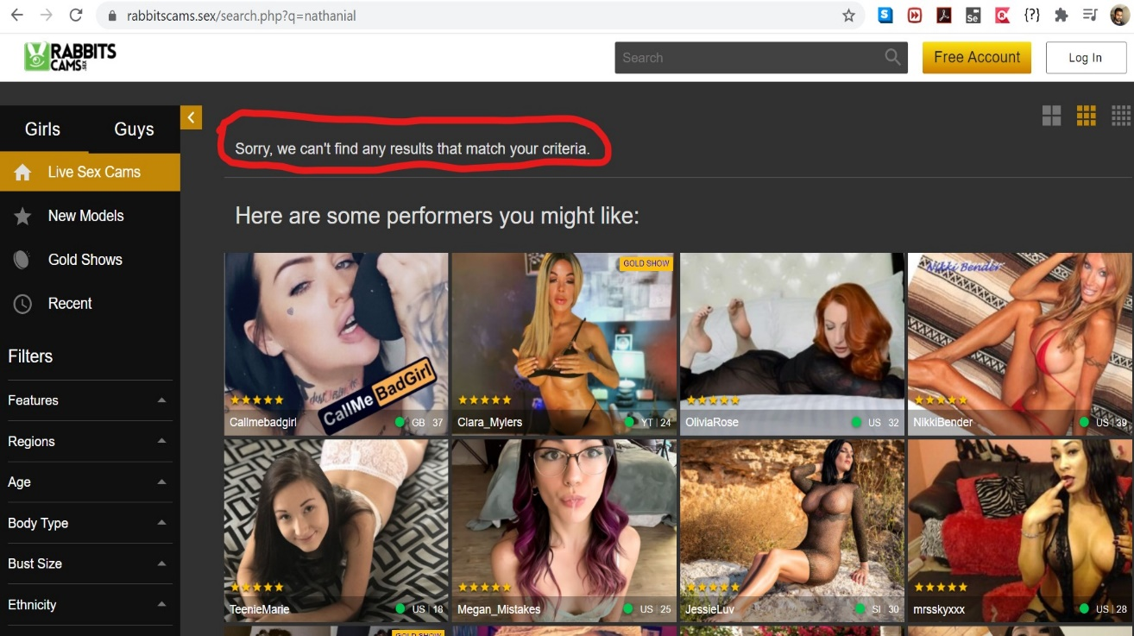

2. Written test case: Write a functional test case that could be used for automation based on the mobile version of the following page:

https://www.rabbitsreviews.com/index.html

I have written the testcases in Excel format:

Functional Testcases.xlsx